The small Asian woman was dumb struck.
“Is this really a high school?”
The enormous building looked more like a monument than a school. Its massive face was sheer and imposing. It rose to dizzying heights and must have been able to contain a student body of at least ten- NO- maybe twenty thousand.
“There's no way the class is only 500 students”
When Ms. Kim was approached by the VP of San Graso Academy for girls, her offer was very enticing. A body of only 500 students, in a small town and you’ll start out with a six-figure salary if you transfer NOW.
The offer was extremely unorthodox and while San Graso was on the map, no other teachers or administrators had even heard of the place. But... well... A six-figure salary... eh.
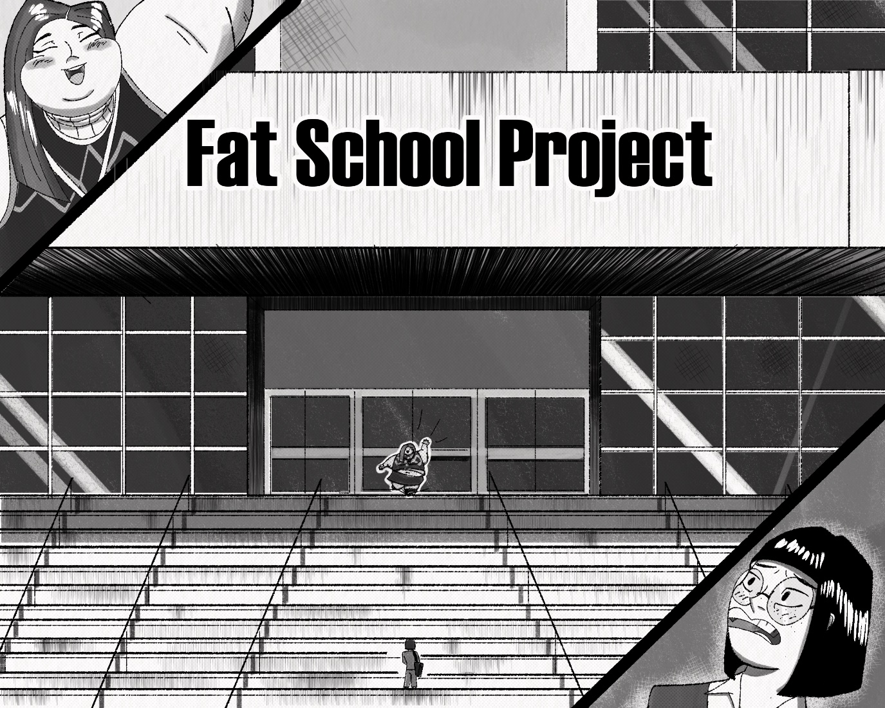
She took the offer and now.
“Here I am,” she said shakily.
“There you are, whew” huffed a young voice.
Past the school's enormous gate, walked….no, scratch that, waddled one of the fattest teenagers Ms. Kim had ever seen. She was wrapped in a bookish sweater vest, along with a plaid skirt, neither of which seemed to fit around her soft mass.
“You must *HUFF* be the new *HUFF* math teacher” The girl wheezed. She was clearly overheating; her pudge was pink and moist. As she moved, her body seemed to bulge and puff out of her garments, each jiggle sending more young flesh spilling out.
“Uh, oh yes and I’m… sorry I just thought I'd be meeting with the VP or...um,” as the tubby teen stopped in front of her, she put on a cute chubby smile, but was still wheezing through her nose, she looked like a balloon swelling and shrinking as she gulped down air while trying not to show it.
“Oh, sweety here.” Ms. Kim brought out a water jug from her bag; it was full of soda.
The girl looked embarrassed, sweet fat cheeks turning rosy. “um, Thank you”, she took the jug and drank. It was then that Ms. Kim saw that the student had a teacher's pass.
Oh, she must be a teacher's aide or something, Amy McDonald? What a… fitting name.
The teacher's attention moved back to the student, who- “oh my”.
With her fat roll of a neck bulging like a frog with each massive gulp, Amy finished the entire two-liter jug, in 5 seconds flat.
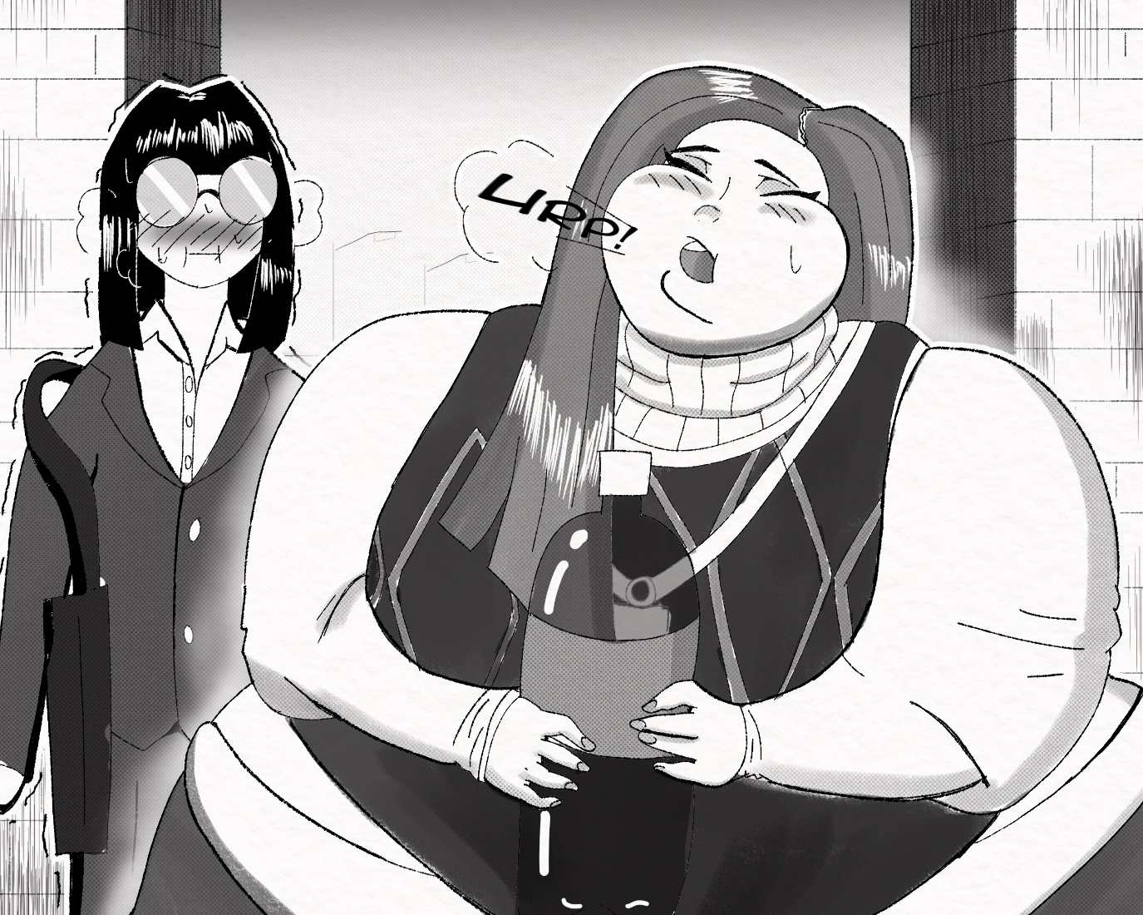
“*BUUUUUUUUUUUURP* oh excuse me”, with a look of relief, Amy gave her back the jug, which turned into guilt as she realized the jug was empty.
“Oh sorry, um *urp* lets go, the VP wanted to meet *UUURP* you”, explained the soda filled fatty. Amy turned, and waddled her way back into the school, Ms. Kim followed. The whole time though, Ms. Kim seemed strangely fixated on the girl. Oh my, she’s so.... big, and round, and jiggly, and adorable, oh I could just NO!
She shook her head. No, no, no. She is a student, and that kind of thinking is completely inappropriate. Oh, but she's so cute and faaaaat.
It didn’t help matters that Amy's constant sloshing and jiggling made the soda in her belly fizz and fill her guts with gas. The girl belched and bubbled the whole walk.
“Ms. Kim, are you *urp* drooling?” Amy asked.
“NO!” Ms. Kim replied, mouth a drool.
“I was just...um”, Amy suddenly got a knowing look on her face.
“Don't worry, I know how you feel. '' The girl slowly rubbed her enormous stomach, biting her lower lip as it growled hungrily.
“You-you do?” Ms. Kim's face was red.
“Yeah...I'M HUNGRY TOO!” Amy whined. “I haven't had anything since this morning, and all I had was like 4 stacks of pancakes, and there were only 3 *Burp* packs of bacon left!”
“Oh...y-yeah...h-hungry”, While she may not have been hungry, Ms. Kim was very, very thirsty.
…
She could hardly believe it, but the inside of the school was even stranger than the outside. First of all, most if not all of the lockers seemed to be replaced with vending machines, big ones, some even had things like donuts and tubs of ice cream. The banners around the school all had bizarre slogans like
GO FATTIES!!!!!
CONSUME SLEEP CONSUME
SAN GRASO COMPETITIVE EATING TEAM
The walls were covered in educational posters with clearly inaccurate information on them, like a food pyramid that was composed entirely of meat, dairy, and carbs. There was one poster promoting the health benefits of obesity in young girls, another which told the students to eat 5,000 calories per day at minimum.
Then there were the benches, every corner seemed to have them, heavy metal things that looked like they could support a cow. Amy quickly plopped her girth down like a squishy meteor.
The sound of a bus door hissing open could be heard.
“Oh, looks like the first bus arrived” noted Amy
Ms. Kim looked behind her, ready to greet some of her new students…. oh...oh my.
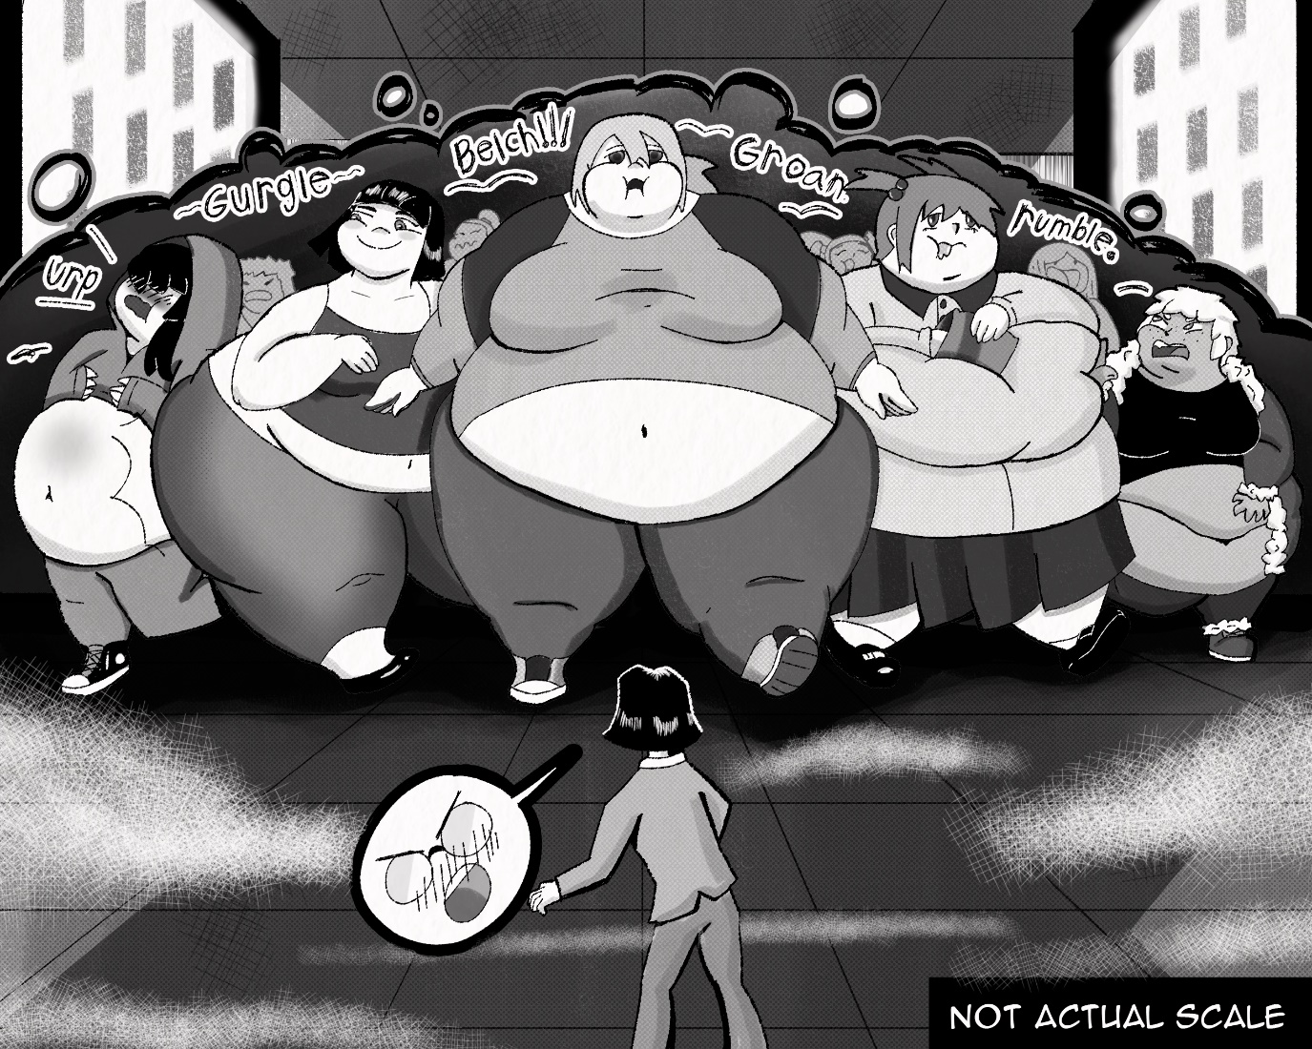
It was like a stampede of female hippos. There must have only been a few dozen but they filled up the wide hallway. Each student was at least 200 pounds, all of them flush and swollen looking as they huffed and puffed with the effort of walking. Some of them looked soft and doughy, others looked like they had been filled with air, bulbous and round. Ms. Kim grew dizzy, as the wall of steaming hot flesh bulged toward her. As they approached, a wave of hot air hit the tiny teacher, as well as a smell like a cheap buffet, every food you can think of mixing together into a single new smell. The girls' bodies were also making plenty of noise, a loud churning and gurgling, moaning, and burbling, boiling, stirring, sloshing, stretching, all these sounds and more. Ms. Kim was shaking like a newborn deer. Oh god, oh god, keep it together, don't look at their youthful, over engorged little bodies. Don't think about how much food they must eat. Don't think about feeding them more. Don't think about how good it would feel to just.
“Oh good, they're all freshmen *urp*” Amy said.
“What?” asked the vibrating teacher
“Oh, I just mean... well” Amy grimaced.
“The juniors and seniors are all way bigger, and when they are all in the hall, they can get...kind of...stuck”. Bigger…. STUCK?
“Oh no” Kim whispered. She Rubbed her thighs together at the thought.

After she caught her breath, Amy was finally able to lead Ms. Kim to the VP.
“Ah Ms. Kim! So glad to see you!”
Vice principal Molly Tanner was a big woman, loud and round. She had curly blond hair and a chubby dimpled moon of a face, which smiled back at the teacher with gleaming blue eyes. When they first met, Ms. Kim thought of the woman as fat-which she was-but after the sheer display of human excess that were the students, she looked almost slim.
“I know this is very short notice, but our last math teacher quit without warning”
Ms. Kim raised her eyebrows. “Oh my gosh, what happened?”
“Oh” Molly chewed on her words for a moment. “She didn't like how things were done around here”
“O-oh?” Ms. Kim wondered if it had anything to do with...well...every single thing she had seen so far.
“Don't worry though” The large woman gave Mrs. Kim a cat-like grin. “I'm sure you will absolutely love it here”. Okay, a bit ominous, but at this point Ms. Kim was far too curious about what was up with this place to leave now.
And so, Molly showed Ms. Kim her new classroom, unsurprisingly it was huge. There were only ten desks, but they were so big and so spread out that they filled the room evenly.
“Don't worry, we already have a lesson plan ready to go, it's the only file on this computer, just boot it up and go from there”
“O-okay...um, excuse me but can I ask you something?” The small woman looked around nervously.
“Of course”
“Um…. why are the students.... why is this school so...uh” where did she even start? Suddenly, she felt a bit rude. What would she ask? So why are all the girls such fatties? Why does this school feel like fetish material? Why do all the students have to be so goddamn succulent and plump?
BING BONG
“Oh, class is about to start” Molly said matter of factly
“W-Wait, right now? But I just got here, how am I-”
“Relax dear” The large woman put her plump hands on Ms. Kim's shoulders, and pulled her so close that her giant G-cup breasts were pressing against Ms. Kim’s itty bitty A-cups.
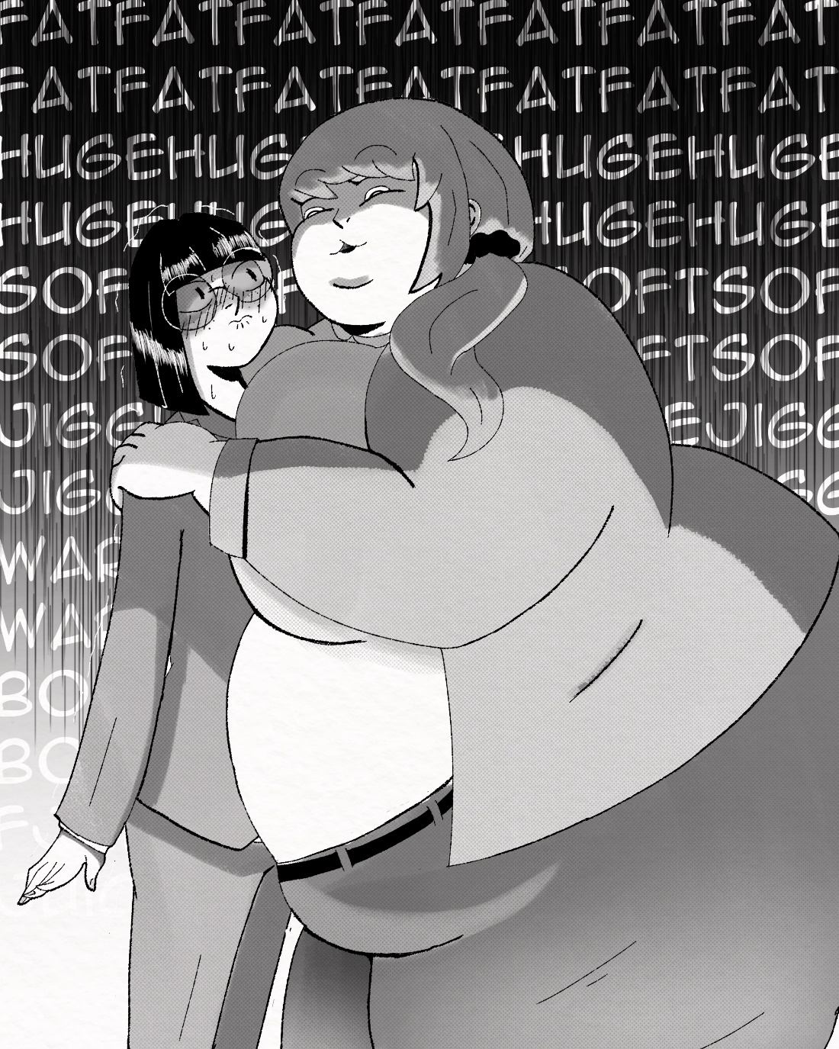
“I told you, this job is easy, Just” Molly leaned in close and whispered.
“Have fun”. That last utterance sent a chill down Mrs. Kim's spine.
The students began to waddle to class, and Ms. Kim began to frantically look through the lesson plan on her computer, though it was impossible to concentrate considering she was so...um… activated, from Molly's massive billowy body. I bet she could bury me under all that soft, warm-NO, FOCUS! For the most part it was pretty bog standard, for the most part.
“Why is there a folder labeled punishments?” she began to read it.
For students whose brains are too fat and stupid to understand the material, spice up your lesson with some of the following punishments. Spanking, name calling, groping, stuffing, group stuffing, confiscation of clo- She closed the document. Her face went red, tears lined the corners of her eyes.
“Is this some kind of elaborate joke?”
The class went underway. this was a freshmen class, so the lesson was pretty easy, however.
“Miss Kim, how do I solve this problem?”
“Miss Kim, what does this mean?”
“Miss Kim, can I get a snack?”
These girls were… not the brightest. They barely even knew division, hell some of them struggled remembering their multiplication tables and God did they ask for snacks a lot.
“Miss Kim, can I go to the vending machine?”
“Miss Kim, can I eat lunch here?”
“Miss Kim, When's lunch?”
“Miss *Buuuuurp* Miss Kim?” a tiny, strained voice came next, coming from a small...well. Relatively small, Latina girl whose name escaped her.
“Yes?” Miss Kim said already tired.
“I’m sorry, I don't know any of this but, *URP* could you please not stuff me today? *URRP*”
“Ok I... what?”
Ms. Kim suddenly noticed just how bloated and full this girl seemed. She wore nothing but a tank top and shorts, her caramel flesh bulged around the fabric like dough. The girl was wheezing and holding a massively distended belly, like she was about to pop.
“It's just… I had a huge breakfast, and I don't *Burp* think I can handle any more food, please could you just punish me with something else? I'm begging…Oooohhh” The girl's body slowly started to gurgle and shake as she wore a nauseated expression.
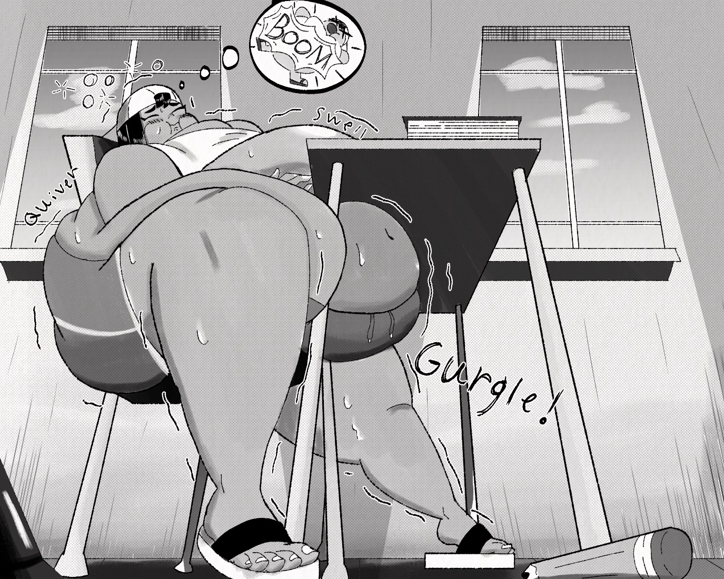
“Uh...Sweety are you ok?” Ms. Kim asked.
The girls' guts continued to bubble and boil like crazy, and from where Ms. Kim was standing it looked like her student was about to.
“I-I think I’m gonna...I’m gonna…” her gassy sweaty balloon of a belly suddenly bulged into her desk, and the Latinas cheeks puffed up before a massive.
“*BUUUUUUUUURRRRRRRRP*” The girl let loose an enormous belch that vibrated her vast, over blown young body. She seemed to visibly deflate, revealing the mind-blowing amount of gas that must have been building inside her all morning.
“Oooh no more, why did I eat so many burritos?” the girl clutched her round body in discomfort and let out a long low moan as she looked...oh god… Ms. Kim could swear it looked like she was slowly, almost unnoticeably swelling back up, building up another earth-shattering belch. Ms. Kim had no words, she just slowly walked back to her desk, rigid as a board.
“I told you not to ask her that” one girl whispered
“Now she’ll probably feed you even more you dumb gas bomb”
“Honestly I wouldn't mind seeing that”
She ignored the whispering of other students and simply sat at her desk. She looked around at her class, her fat, stupid, hungry, young, fleshy, soft squishy class.
“Ooooh no.” she felt a damp spot on her panties.
By the end of her first day, Ms. Kim would definitely need a new pair.

